# Custom Geographic Maps with Senegal Administrative Boundaries

1) Go to <https://github.com/paulvanmol/senmap> (on a browser on the Virtuallab) and download a copy of the repository. (Click on Code: Download Zip)

2) Select zip file and unzip it to a folder on (Virtuallab) computer:

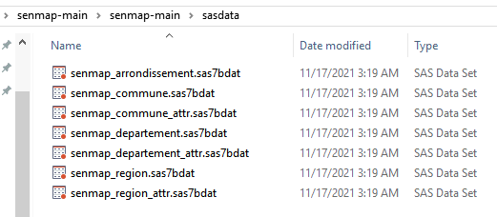

Go to SAS Drive and login as a user with Administrative Capabilities (on our training image: Christine+Student1)

4) Import Polygon datasets:

There are polygon datasets with information of Regions, Departements and Communes.

To load the maps of the most recent information you can select the maps.

* • senmap_region.sas7bdat
* • senmap_departement.sas7bdat
* • senmap_arrondissement.sas7bdat
* • senmap_commune.sas7bdat

To load the polygon dataset in memory, you can import them

5) Select Manage Data>Import>Local Files>

6) Select /senmap/sasdata/senmap_departement.sas7bdat et senmap_departement_attr.sas7bdat

Select CASUSER as the Target Location to import the map dataset and the attribute dataset:

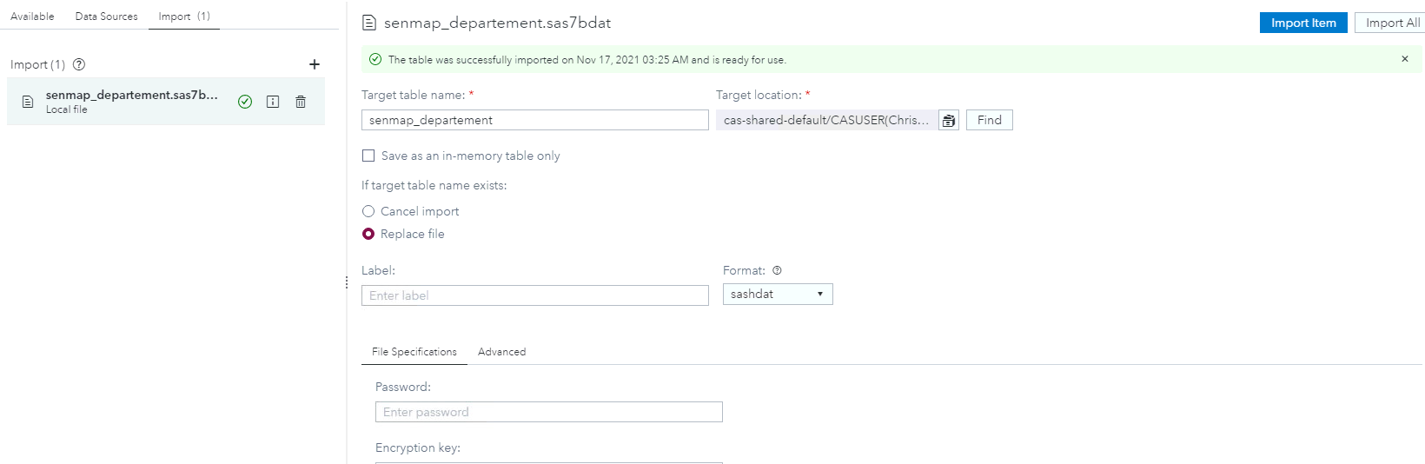

Select Data>Data Sources>CASUSER or PUBLIC and verify that the imported files are now available in your library

## Create a Report on Population Data in Senegal

Select the SENMAP_Departement_ATTR dataset in your SAS Visual Analytics report.

In the Data Panel:

You can select the Data Items:

NOM (Nom du Departement).

Change the Classification from Category to Geography

In the window: Edit Geography Item:

In the Geography Data:

Select Geographic data provider

Geographic Data provider: select New

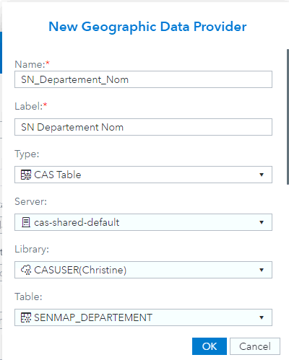

ID column is NOM

Sequence is __seq__

Change the projection to EPSG:32628

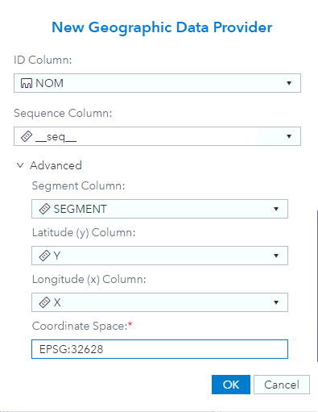

Then create a Region Map with Pop_TOTAL and Nom as geography data item:

